HR Employee Survey Dashboard
Capstone Project Report
Prepared by:
Bello, Kabirat Omolola
LinkedIn: Bello Kabirat
GitHub: Kabirat-Bello

1. Introduction
Employee satisfaction is one of the key indicators of an organization's overall performance and productivity. Organizations that regularly assess employee engagement are better equipped to identify workplace strengths, address employee concerns, and make informed management decisions.
The objective of this project was to develop an interactive HR Employee Survey Dashboard using Microsoft Power BI. The dashboard analyzes employee survey responses to identify satisfaction trends, highlight areas requiring improvement, and provide actionable insights that can support organizational decision-making.
The dashboard combines key performance indicators (KPIs), visualizations, and summary insights to enable management to quickly understand employee sentiment across different survey questions and departments.

2. Project Objectives
The objectives of this project are to:
- Analyze employee survey responses using Power BI.
- Identify the survey questions with the highest and lowest satisfaction levels.
- Examine employee satisfaction across different departments.
- Visualize the overall distribution of employee responses.
- Generate meaningful insights from the survey results.
- Provide recommendations to improve employee satisfaction and engagement.

3. Dashboard Overview
The HR Employee Survey Dashboard presents an overview of employee engagement through several interactive visualizations.
The dashboard includes:
- Key Performance Indicators (KPIs) displaying:
  - Total Responses
  - Number of Departments
  - Number of Managers
  - Number of Directors
- Top Survey Questions by Employee Satisfaction showing the survey questions that received the highest average satisfaction scores.
- Top 10 Departments by Employee Satisfaction highlighting departments with the highest employee satisfaction.
- Areas Needing Improvement identifying survey questions with the lowest satisfaction scores.
- Employee Response Distribution illustrating the proportion of employees who selected Agree, Strongly Agree, Disagree, Strongly Disagree, or Not Applicable.
Together, these visualizations provide management with a comprehensive overview of employee engagement within the organization.
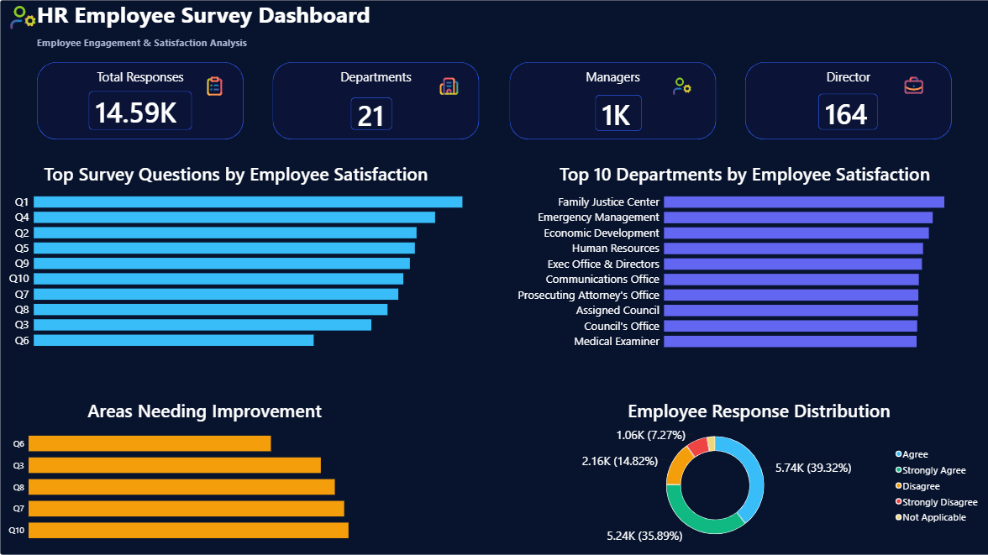
Figure 1: HR Employee Survey Dashboard

4. Key Insights
4.1 Employee Satisfaction
The dashboard indicates that several survey questions received high average satisfaction scores. These results suggest that employees generally have positive perceptions regarding certain aspects of their work environment.
High-performing survey questions reflect areas where the organization is successfully meeting employee expectations and maintaining positive workplace experiences.

4.2 Areas Needing Improvement
The analysis identified Q6, Q3, Q8, Q7, and Q10 as the survey questions with the lowest average satisfaction scores.
These questions represent the areas where employees expressed comparatively lower levels of satisfaction and therefore require additional attention from management.
Improving these areas has the potential to significantly enhance overall employee engagement and organizational performance.

4.3 Department Performance
The dashboard reveals noticeable differences in employee satisfaction across departments.
Some departments consistently achieved higher satisfaction scores than others, suggesting that workplace experiences vary throughout the organization.
Management should investigate the practices implemented within high-performing departments and consider adopting similar strategies in departments with lower satisfaction levels.

4.4 Overall Employee Response Distribution
The Employee Response Distribution chart shows that the majority of responses fall within the Agree and Strongly Agree categories.
This indicates that employees generally have positive perceptions of their workplace, although the presence of Disagree and Strongly Disagree responses highlights opportunities for continuous improvement.

5. Recommendations
Based on the findings from the dashboard, the following recommendations are proposed:
1. Strengthen Employee Recognition
Organizations should establish or improve employee recognition programs to acknowledge outstanding performance and motivate employees.

2. Improve Communication
Management should encourage open communication by conducting regular meetings, feedback sessions, and employee engagement activities.

3. Invest in Leadership Development
Providing leadership and management training will help supervisors and managers better support employees and improve workplace relationships.

4. Focus on Low-Scoring Survey Areas
Management should carefully review the survey questions with the lowest satisfaction scores and develop targeted improvement strategies.

5. Learn from High-Performing Departments
Best practices from departments with high employee satisfaction should be shared across the organization to improve consistency.

6. Conduct Regular Employee Surveys
Periodic employee satisfaction surveys should be conducted to monitor progress, evaluate implemented strategies, and identify new concerns before they become significant issues.
6. Conclusion
The HR Employee Survey Dashboard successfully provides a comprehensive analysis of employee satisfaction using Microsoft Power BI.
Through the use of interactive visualizations and key performance indicators, the dashboard highlights organizational strengths, identifies areas requiring improvement, and supports data-driven decision-making.
The analysis shows that although employees generally express positive workplace experiences, there are specific survey areas that require management attention. By implementing the recommendations outlined in this report, organizations can improve employee engagement, increase job satisfaction, and foster a more productive work environment.
Overall, this project demonstrates the effectiveness of Power BI as a business intelligence tool for transforming employee survey data into meaningful insights that support strategic decision-making.

